**Udacity AIND Project II – Heuristic Analysis**

**Rongyu Lin**

**Heuristic I. #my_moves – 2*#opponent_moves**

Inspired by the lectures, this heuristic can reduce opponent’s moves and keep its own moves.

**Heuristic II. #my_moves + distance_between_player - #opponent_moves**

This heuristic gives bonus to the distance between current position of the two players. The more distant they are, the more bonus player gets, which indicates that player has more moves when it is far from its opponent. After comparing L1-norm with L2-norm distance in the same heuristic, I found L2-norm distance is a better choice. Therefore, distance_between_player means L2-norm distance in this heuristic.

**Heuristic III. #my_moves + (player location is at corner ? -2 : 0) - #opponent_moves**

The third heuristic gives penalty when current location of player is at corner, since player will definitely lose at least two possible moving directions when in the corner. Thus, if the current location of player is at corner, #my_moves will be reduced by 2 as a penalty.

Below is the tournament result. AB_Custom is Heuristic I, AB_Custom_2 is Heuristic II and AB_Custom_3 is Heuristic III.

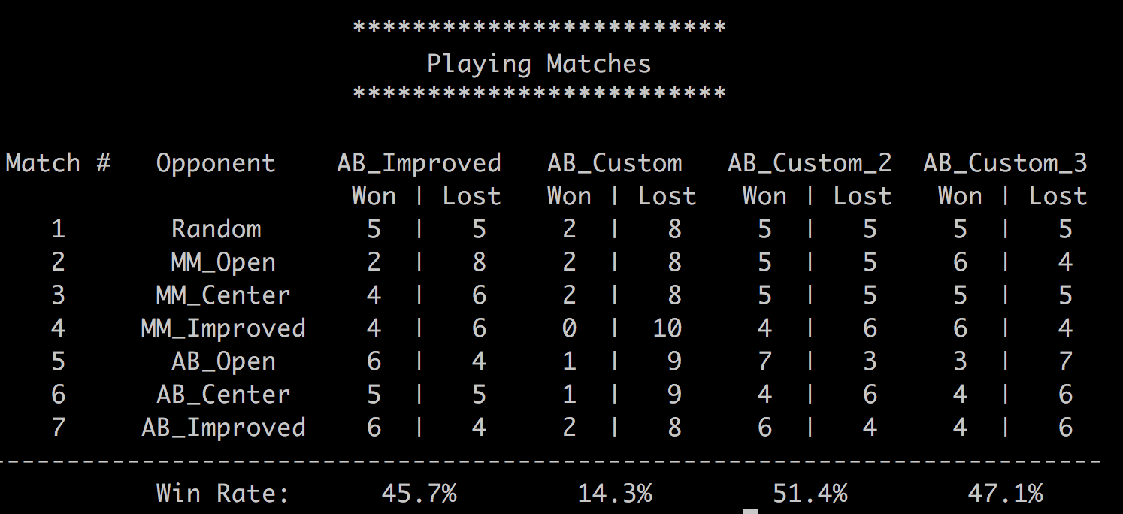

We see from the result that Heuristic II outperforms the baseline, AB_Improved in nearly all matches. Heuristic III also performs really good, but not as well as Heuristic II does. Heuristic I, however, performs even worse than baseline.

**Result Analysis**

In my opinion, Heuristic II and III should have similar effect on winning rate, since they both contains #opponent_moves and another feature of player (is_at_corner and distance_between_players). Heuristic II should perform better and more stable than Heuristic III since it is more dynamic (distance in II can vary but penalty in III can only be -2 or 0) when treating the player. Computational cost of Heuristic II and III should also be similar because checking whether a player is at corner and calculating distance between two players cost similar amount of time. And both of them take slightly longer than Heuristic I since they do more calculation. In treating player and opponent, Heuristic I only treat player and opponent with their number of moves. Heuristic II and III treat opponent the same way Heuristic I do, but treat the player differently. Heuristic III add one more static penalty to player’s score, while Heuristic II add dynamic bonus.

In summary, since:

(i). Heuristic II has the best performance in tournament

(ii). Computational cost of Heuristic II is slightly larger than Heuristic I and similar to Heuristic III

(iii). Due to the randomness of isolation, a dynamic strategy should be better than a static one.

Therefore, Heuristic II is recommended!